### ****Group Members:****

Momina Ishtiaq – [4667-FOC/BSCS/F22]

Maria Saba – [4667-FOC/BSCS/F22]

Wajeeha Nawaz – [4667-FOC/BSCS/F22]

### ****Acknowledgments:****

We would like to express our sincere gratitude to Mam Maria for their invaluable guidance and support throughout this project. Additionally, we appreciate chatgpt for their contributions and assistance in completing this work.

### ****Content****

**Introduction**

* 1. Overview of Metaheuristic Algorithms
  2. Genetic Algorithms
  3. History of Genetic Algorithms

**Components, Structure, and Terminology of Genetic Algorithms**

* 1. Fitness Function
  2. Population
  3. Chromosomes
  4. Selection
  5. Crossover (Recombination)
  6. Mutation

**Generational Progression in Genetic Algorithms**

**Genotype vs. Phenotype in Genetic Algorithms**

**Pseudocode for Genetic Algorithm**

**C++ code for Genetic Algorithm**

**Why Do We Use Genetic Algorithms?**

* 1. Exploration of Large Search Spaces
  2. Global Optimization
  3. Adaptability
  4. Robustness

• **Advantages of Genetic Algorithms Over Traditional Algorithms**  
1. Flexibility  
2. No Need for Gradient Information  
3. Parallelism  
4. Handling Non-linear, Non-convex, and Multi-modal Problems

• **Scalability and Flexibility of Genetic Algorithms**  
1. Scalability  
2. Flexibility

• **Efficiency in Solving Complex Problems**  
1. Efficient Global Search  
2. Convergence Speed  
3. Handling Constraints

• **Efficiency Analysis of Genetic Algorithms**  
1. Time Complexity  
2. Space Complexity  
3. Efficiency Analysis in Real-World Problems

• **Real-World Applications of Genetic Algorithms**  
1 Optimization Problems  
 1.1 Knapsack Problem  
 1.2 Job Shop Scheduling Problem  
2 Machine Learning  
 2.1 Feature Selection  
3 Real-World Examples  
 3.1 Routing and Logistics  
 3.2 Disaster Management  
 3.3 Resource Allocation

• **Comparison of Genetic Algorithm (GA) with Other Metaheuristic Algorithms**

• **Challenges and Limitations of Genetic Algorithms (GAs)**

• **Conclusion**

• **References**

### Introduction:

### Overview of Metaheuristic Algorithms and Genetic Algorithms

Metaheuristic algorithms are a class of optimization techniques designed to solve complex problems where traditional methods may struggle. These algorithms draw inspiration from natural and biological processes, aiming to explore a solution space efficiently to find near-optimal or optimal solutions. Unlike exact optimization methods, metaheuristics do not guarantee an exact solution but are effective for solving problems that are computationally intensive or have numerous local optima.

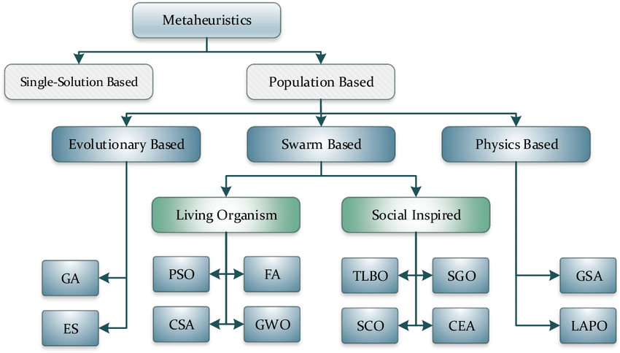

### Genetic Algorithms

Among the various metaheuristic techniques, Genetic algorithms (GAs) are computational search and optimization techniques inspired by the principles of natural selection and evolutionary biology. They are widely used to solve problems where traditional methods may struggle, particularly in cases involving complex, multidimensional, or poorly understood solution spaces. By emulating the processes of selection, reproduction, crossover, and mutation observed in biological systems, GAs aim to find optimal or near-optimal solutions through iterative improvement over successive generations.

At the core of genetic algorithms lies a **population of candidate solutions**, represented as chromosomes. These chromosomes encode potential solutions to a given problem, often using numerical arrays, binary strings, or other structures. Over iterations, the algorithm evaluates these candidates based on a **fitness function**, which measures their quality or suitability to solve the problem at hand. This fitness function acts as a guiding force, steering the population toward better solutions by simulating survival of the fittest.

### History of Genetic Algorithms

The history of Genetic Algorithms (GAs) is rooted in the intersection of biology, computer science, and mathematics, dating back to the mid-20th century. The foundational concepts of GAs were inspired by Charles Darwin's theory of natural selection, which emphasizes survival of the fittest. Over the years, these biological principles have been adapted into computational frameworks for solving optimization problems.

1. **Early Inspirations (1950s-1960s):**  
   The concept of applying evolutionary principles to computation was first introduced in the 1950s and 1960s. Alan Turing hinted at the idea of evolving solutions computationally in his early work on artificial intelligence. However, the first concrete steps were taken by John Holland, who is credited as the father of Genetic Algorithms.
2. **John Holland’s Contribution (1970s):**  
   In the 1970s, John Holland formalized the concept of Genetic Algorithms while working at the University of Michigan. His seminal book "Adaptation in Natural and Artificial Systems" (1975) laid the theoretical foundation for GAs. Holland proposed the use of genetic operators such as selection, crossover, and mutation to evolve solutions for optimization problems. He also introduced the idea of encoding potential solutions as strings (chromosomes) and applying evolutionary mechanisms to refine them iteratively.
3. **Practical Applications (1980s):**  
   During the 1980s, GAs gained popularity as researchers began applying them to practical problems in fields like engineering, scheduling, and machine learning. David E. Goldberg, one of Holland's students, played a significant role in advancing GAs through his book "Genetic Algorithms in Search, Optimization, and Machine Learning" (1989), which became a standard reference in the field.
4. **Diversification and Advancements (1990s):**  
   In the 1990s, GAs were extended and hybridized with other optimization techniques. Researchers began exploring more complex representations for chromosomes, such as real numbers and permutations, to address a wider range of problems. Genetic Algorithms were applied to domains like finance, robotics, and bioinformatics, showcasing their versatility and adaptability.
5. **Modern Era (2000s-Present):**  
   Today, GAs continue to evolve, benefiting from advancements in computational power and parallel processing. They are often combined with other metaheuristic techniques like particle swarm optimization and simulated annealing to create hybrid algorithms. GAs have found applications in machine learning, artificial intelligence, and optimization problems in diverse fields such as healthcare, logistics, and environmental science.

**Components, Structure, and Terminology of Genetic Algorithms**

Genetic Algorithms (GAs) are optimization techniques inspired by biological evolution. They solve problems by iteratively improving a population of candidate solutions using principles like natural selection, crossover, and mutation. Below, we explain the key components, structure, and terminology central to GAs.

**1. Fitness Function**

The **fitness function** evaluates how well a potential solution (or chromosome) solves the given problem.

* **Objective**: To quantify the "fitness" or adaptability of a chromosome based on the problem's requirements.
* **Example**: In a maximization problem, the fitness function assigns higher scores to better-performing solutions.
* **Importance**: It guides the evolution process, as fitter chromosomes are more likely to be selected for reproduction. A carefully designed fitness function is crucial to avoid misleading the algorithm or causing premature convergence to suboptimal solutions.

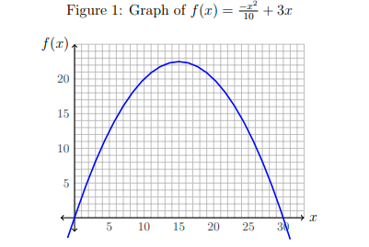

The fitness function must be more sensitive than just detecting what is a ‘good’ chromosome versus a ‘bad’ chromosome: it needs to accurately score the chromosomes based on a range of fitness values, so that a somewhat complete solution can be distinguished from a more complete solution

**2. Population**

The **population** is a collection of candidate solutions (chromosomes) maintained throughout the algorithm.

* It serves as the pool from which new generations evolve.
* A typical population size is chosen based on the problem's complexity and computational resources.

**3. Chromosomes**

A **chromosome** represents a candidate solution to the problem, encoded as an array of values.

* **Structure**:  
  For a problem with NparN_{par}Npar​ parameters, a chromosome might be encoded as: chromosome=[p1,p2,...,pNpar]\text{chromosome} = [p_1, p_2, ..., p_{N_{par}}]chromosome=[p1​,p2​,...,pNpar​​] where pip_ipi​ represents a specific parameter.
* **Encoding**: Chromosomes can be binary strings (e.g., 010101), real numbers, permutations, or other formats depending on the problem.
* **Representation Flexibility**: For binary solutions, parameters are concatenated into a single bit string.

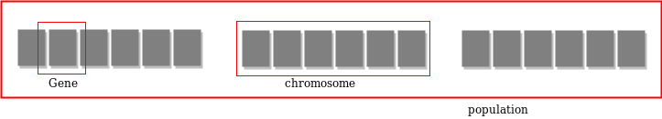

**4. Selection**

**Selection** determines which chromosomes are chosen to reproduce, favoring those with higher fitness.

* **Purpose**: To mimic natural selection by giving fitter chromosomes a higher likelihood of passing their genes to the next generation.
* **Methods**:
  + *Roulette Wheel Selection*: Probabilities are proportional to fitness scores.
  + *Tournament Selection*: Groups of chromosomes compete, and the best performer is selected.
* **With Replacement**: A chromosome can be selected multiple times, increasing its influence on the offspring.

**5. Crossover (Recombination)**

The **crossover** operator simulates genetic recombination in biological reproduction.

* **Mechanism**:  
  Two parent chromosomes exchange parts of their structure to produce offspring.
  + Example:  
    If parent chromosomes are: Parent 1:[11010111001000], Parent 2:[01011101010010]
  + After a crossover at the 4th bit: Offspring 1:[11011101010010],Offspring 2:[01010111001000]
* **Importance**: Combines good traits from parents to explore new regions of the solution space.

**6. Mutation**

**Mutation** introduces random changes to chromosomes to maintain diversity in the population.

* **Example**: Flipping bits in a binary chromosome (e.g., 0101 becomes 0111).
* **Probability**: Mutation rates are typically low (e.g., 0.001) to avoid destabilizing the search process.
* **Purpose**:
  + Prevents premature convergence by introducing new genetic material.
  + Avoids getting stuck in local optima, promoting exploration of the solution space.

**Generational progression** refers to the process of evolving a population over successive iterations (generations) in a genetic algorithm. Each generation builds on the previous one by applying genetic operators (selection, crossover, mutation) to create a new population. The goal is to improve the fitness of solutions over time and move closer to an optimal or near-optimal solution.

### Genotype vs. Phenotype in Genetic Algorithms

**Genotype** and **phenotype** are concepts borrowed from biology to represent the internal encoding of a solution and its external manifestation, respectively.

**Genotype vs. Phenotype**

| **Aspect** | **Genotype** | **Phenotype** |
| --- | --- | --- |
| **Definition** | Encoded representation of a solution. | The expressed form of the solution. |
| **Domain** | Internal (e.g., binary or numeric). | External (problem domain). |
| **Representation** | Binary strings, arrays, or other data structures. | Decoded form used in the fitness evaluation. |
| **Manipulation** | Modified by genetic operators (crossover, mutation). | Evaluated directly for fitness. |
| **Example** | Binary string: 101001. | A neural network with weights [3.5, 4.2]. |
| **Role** | Represents the "blueprint" of the solution. | Represents the actual "manifestation." |
| **Mapping** | Requires decoding to produce a phenotype. | Directly corresponds to the problem's solution. |

**Pseudocode for Genetic Algorithm**

**1. Initialize population P with size N randomly**

**2. Evaluate fitness of each individual in P**

**3. Repeat until stopping criteria met:**

**a. Select individuals for reproduction using a selection method (e.g., roulette wheel)**

**b. Apply crossover to selected parents to create offspring**

**c. Apply mutation to the offspring**

**d. Evaluate the fitness of the offspring**

**e. Select individuals for the next generation (either by replacing the whole population or keeping the best)**

**f. If stopping criteria are met (e.g., max generations or fitness threshold), terminate**

**4. Return the best solution found**

**How Genetic Algorithm Works - Step by Step:**

**Genetic Algorithm (GA)** is a search heuristic inspired by the process of natural selection. It is used to find approximate solutions to optimization and search problems. Here's a detailed explanation of the steps involved in how a genetic algorithm works:

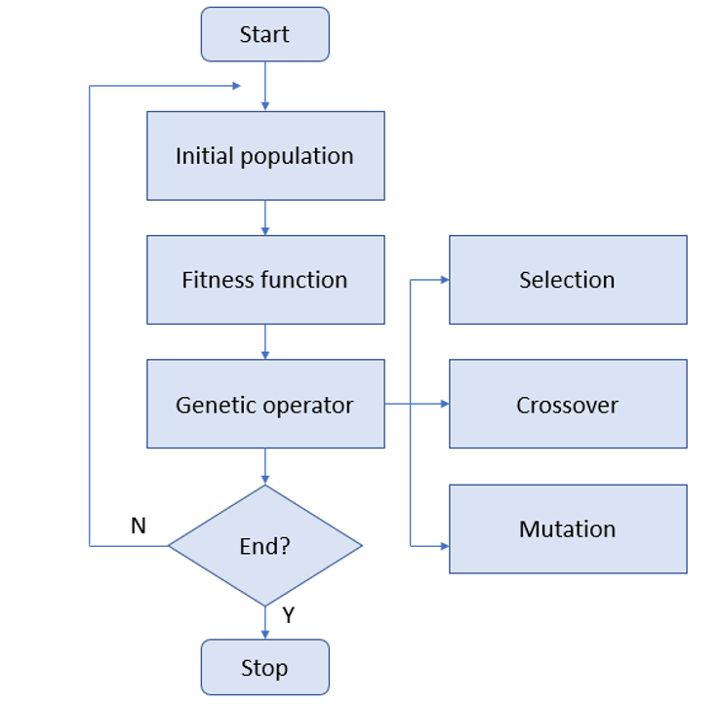

**1. Initialization**

* **Purpose**: To create the initial population of solutions (individuals).
* **Explanation**: The first step is to generate an initial population, usually randomly, though sometimes heuristics or specific constraints can guide the generation.
  + **Chromosomes**: Each individual in the population is represented as a chromosome (which encodes a potential solution). A chromosome can be represented as a string of binary values, real numbers, or any other suitable representation.
  + **Population Size**: A population size is chosen, often based on computational constraints or experimentation, and a set of chromosomes is randomly initialized.

**Example**: If you're solving a traveling salesman problem (TSP), a chromosome could represent a possible route through the cities.

**2. Fitness Evaluation**

* **Purpose**: To evaluate how good each solution (chromosome) is in the current population.
* **Explanation**: The fitness function is used to assign a fitness score to each individual in the population based on how well it solves the problem. A higher fitness score indicates a better solution.
  + **Fitness Function**: This is problem-specific and tells us how good a solution is. For example, in the TSP, the fitness function could calculate the total distance of the route represented by the chromosome.
  + **Scaling**: The fitness values may be scaled or normalized to ensure they are comparable across the population.

**Example**: For a traveling salesman problem, the fitness could be the inverse of the total distance, meaning that shorter paths have higher fitness.

**3. Selection**

* **Purpose**: To select individuals from the population to form the mating pool, based on their fitness scores.
* **Explanation**: In the selection step, individuals are chosen for reproduction based on their fitness. The better the fitness, the higher the chance an individual has of being selected.
  + **Roulette Wheel Selection**: The probability of an individual being selected is proportional to its fitness. Individuals with higher fitness scores will have a larger slice of the "wheel" and thus a greater chance of being selected.
  + **Tournament Selection**: A group of individuals is randomly selected, and the best individual from this group is chosen.
  + **Rank Selection**: Individuals are ranked according to their fitness, and selection is based on their rank rather than absolute fitness.

**Example**: A chromosome with a fitness of 90% has a higher chance of being selected for reproduction than one with a fitness of 50%.

**4. Crossover (Recombination)**

* **Purpose**: To combine the genetic material of two parent chromosomes to create offspring.
* **Explanation**: In this step, two parent chromosomes are selected from the mating pool, and they undergo crossover to exchange genetic material. This simulates the biological reproduction process.
  + **Crossover Point**: A random point is selected on the parent chromosomes, and their segments are swapped to create new offspring.
  + **Crossover Rate**: This is the probability that crossover will occur. It is typically high (e.g., 70-90%).

**Example**: For binary representation, if Parent 1 = 110010 and Parent 2 = 101101, a crossover at the 3rd bit could produce offspring as:

* Offspring 1 = 110101
* Offspring 2 = 101010

**5. Mutation**

* **Purpose**: To introduce genetic diversity and avoid local optima.
* **Explanation**: After crossover, mutation is applied to the offspring with a small probability. Mutation involves making small, random changes to a chromosome.
  + **Mutation Rate**: The probability of a mutation occurring, typically a small value (e.g., 0.01 or 1%).
  + **Mutation Type**: For binary chromosomes, mutation could involve flipping a bit; for real-number chromosomes, it could involve adding a small random value.

**Example**: If an offspring chromosome is 110101 and a mutation is applied at the 2nd bit, the resulting chromosome could be 100101.

**6. Termination Criteria**

* **Purpose**: To stop the algorithm once a solution is found or a specific condition is met.
* **Explanation**: Genetic algorithms typically iterate for a set number of generations or until a certain threshold of fitness is reached. Some common termination criteria include:
  + **Maximum Generations**: A predefined number of generations after which the algorithm stops.
  + **Convergence**: If the population reaches a state where the fitness no longer improves, the algorithm might stop.
  + **Target Fitness**: If a solution with a fitness above a certain threshold is found, the algorithm terminates early.

### C++ Code:

#include <iostream>

#include <ctime>

#include <cstdlib>

using namespace std;

// Constants

const int POPULATION_SIZE = 10;

const int CHROMOSOME_LENGTH = 10;

const int MAX_GENERATIONS = 10;

const double MUTATION_RATE = 0.1;

const double CROSSOVER_RATE = 0.7;

// Structure to represent a chromosome

struct Chromosome {

int genes[CHROMOSOME_LENGTH];

int fitness;

};

// Function to generate a random chromosome

Chromosome generateRandomChromosome() {

Chromosome chromosome;

for (int i = 0; i < CHROMOSOME_LENGTH; i++) {

chromosome.genes[i] = rand() % 2;

}

chromosome.fitness = 0;

return chromosome;

}

// Function to calculate the fitness of a chromosome

int calculateFitness(Chromosome chromosome) {

int fitness = 0;

for (int i = 0; i < CHROMOSOME_LENGTH; i++) {

if (chromosome.genes[i] == 1) {

fitness++;

}

}

return fitness;

}

// Function to perform crossover between two chromosomes

Chromosome crossover(Chromosome parent1, Chromosome parent2) {

Chromosome child;

int crossoverPoint = rand() % CHROMOSOME_LENGTH;

for (int i = 0; i < crossoverPoint; i++) {

child.genes[i] = parent1.genes[i];

}

for (int i = crossoverPoint; i < CHROMOSOME_LENGTH; i++) {

child.genes[i] = parent2.genes[i];

}

child.fitness = 0;

return child;

}

// Function to perform mutation on a chromosome

Chromosome mutate(Chromosome chromosome) {

for (int i = 0; i < CHROMOSOME_LENGTH; i++) {

if ((double)rand() / RAND_MAX < MUTATION_RATE) {

chromosome.genes[i] = 1 - chromosome.genes[i];

}

}

chromosome.fitness = 0;

return chromosome;

}

// Function to perform selection (Fitness Proportional Selection)

Chromosome select(Chromosome population[], int populationSize) {

int totalFitness = 0;

for (int i = 0; i < populationSize; i++) {

totalFitness += population[i].fitness;

}

int selection = rand() % totalFitness;

int cumulativeFitness = 0;

for (int i = 0; i < populationSize; i++) {

cumulativeFitness += population[i].fitness;

if (cumulativeFitness >= selection) {

return population[i];

}

}

return population[populationSize - 1];

}

int main() {

srand(time(0));

Chromosome population[POPULATION_SIZE];

// Initialize population

for (int i = 0; i < POPULATION_SIZE; i++) {

population[i] = generateRandomChromosome();

population[i].fitness = calculateFitness(population[i]);

}

int bestFitness = 0;

int bestGeneration = -1; // Initialize bestGeneration to -1

for (int generation = 0; generation < MAX_GENERATIONS; generation++) {

Chromosome newPopulation[POPULATION_SIZE];

for (int i = 0; i < POPULATION_SIZE; i++) {

Chromosome parent1 = select(population, POPULATION_SIZE);

Chromosome parent2 = select(population, POPULATION_SIZE);

Chromosome child = crossover(parent1, parent2);

child = mutate(child);

child.fitness = calculateFitness(child);

newPopulation[i] = child;

}

// Replace old population with the new population

for (int i = 0; i < POPULATION_SIZE; i++) {

population[i] = newPopulation[i];

}

// Find the best fitness in the current generation

int currentBestFitness = 0;

for (int i = 0; i < POPULATION_SIZE; i++) {

if (population[i].fitness > currentBestFitness) {

currentBestFitness = population[i].fitness;

}

}

// Update best fitness and track first occurrence

if (currentBestFitness > bestFitness) {

bestFitness = currentBestFitness;

bestGeneration = generation; // Update bestGeneration only when a new best fitness is found

}

// Print intermediate results (optional)

cout << "Generation: " << generation << ", Best Fitness: " << currentBestFitness << endl;

}

// Print the results

cout << "\nOverall Best Fitness: " << bestFitness << endl;

cout << "First Achieved in Generation: " << bestGeneration << endl;

return 0;

### }

### OUTPUT:

### 

### IF we get same multiple best fitness then we choose the first occurrence of best fitness:

### 

**Why Do We Use Genetic Algorithms (GAs)?**

Genetic Algorithms (GAs) are a class of optimization algorithms inspired by the principles of natural evolution. They are used to solve complex problems where traditional methods may struggle or fail. The primary reasons for using GAs include:

1. **Exploration of Large Search Spaces**: GAs can search large, complex spaces without requiring specific knowledge of the problem's structure, unlike traditional methods.
2. **Global Optimization**: GAs are less likely to get stuck in local optima, making them suitable for global optimization problems.
3. **Adaptability**: They can be used for various problem types, from combinatorial optimization to machine learning model tuning.
4. **Robustness**: GAs can handle noisy, dynamic, and uncertain environments, making them robust in real-world applications.

**Advantages of Genetic Algorithms Over Traditional Algorithms:**

1. **Flexibility**:
   * **Traditional algorithms** (e.g., gradient descent, dynamic programming) often require a deep understanding of the problem's mathematical structure.
   * **GAs**, on the other hand, do not require such detailed problem knowledge. They are highly flexible and can be applied to a wide range of problems.
2. **No Need for Gradient Information**:
   * Many traditional optimization methods require gradient or derivative information, which may be unavailable or computationally expensive to calculate. **GAs do not require gradient information**, making them suitable for problems where such data is difficult to obtain.
3. **Parallelism**:
   * **GAs** naturally lend themselves to parallelism as multiple solutions (individuals) can be evaluated and evolved simultaneously. **Traditional algorithms** often require sequential operations, which can be slower.
4. **Handling Non-linear, Non-convex, and Multi-modal Problems**:
   * **Traditional optimization techniques** may struggle with complex, multi-modal (having many local optima) or non-linear problems.
   * **GAs** are effective at dealing with these problems, as they explore the search space more globally and are less likely to get stuck in local minima.

**Efficiency Analysis of Genetic Algorithms (GAs)**

The efficiency of Genetic Algorithms (GAs) can be analyzed in terms of **time complexity** and **space complexity**. While GAs are often not as efficient as traditional algorithms in terms of raw computational time, their **global optimization capabilities** and **flexibility** in handling complex problems often make them more suitable for certain tasks. Let's look at their time and space complexities and how they are analyzed in the context of real-world problems.

**Time Complexity of Genetic Algorithms:**

The time complexity of GAs depends on several factors:

1. **Population Size (P)**:
   * This refers to the number of candidate solutions (individuals) in the population. Each individual must be evaluated, and the larger the population, the more resources (time) are required for evaluation.
2. **Number of Generations (G)**:
   * This represents how many iterations the GA will go through before stopping. More generations allow for better optimization but increase the total time complexity.
3. **Selection Process Complexity**:
   * The selection process determines how individuals are chosen to reproduce based on their fitness scores. In many cases, selection can be done in **O(P)** time.
4. **Crossover and Mutation Operations**:
   * The crossover operation combines parts of two parent individuals to create offspring, and mutation introduces random changes to an individual. Each of these operations can be done in **O(1)** or **O(n)**, depending on the implementation and the size of the individuals (where **n** is the length of the individual).
5. **Fitness Evaluation**:
   * The fitness function evaluates the quality of a solution. The complexity of this evaluation depends on the problem being solved. In many cases, this is the most computationally expensive part, and its complexity could be **O(n)** or even more depending on the specific problem.

Given these factors, the **time complexity** of a single generation is generally:

* **O(P × n)**, where **P** is the population size, and **n** is the length of the individual (e.g., number of genes in a chromosome).

If the GA runs for **G** generations, the overall **time complexity** would be:

* **O(G × P × n)**

In real-world applications, **P**, **G**, and **n** are typically adjusted based on the complexity of the problem and available computational resources.

**Example:**

For an optimization problem with a population size of 1000 individuals, running for 100 generations with individual solutions of length 50 (n = 50), the time complexity would be **O(100 × 1000 × 50) = O(5,000,000)** operations. This is manageable for many problems but can still be computationally expensive depending on the nature of the fitness function.

**Space Complexity of Genetic Algorithms:**

Space complexity refers to the amount of memory used by the algorithm. The main contributors to space complexity are:

1. **Population Storage**:
   * The space required to store the population of individuals, where each individual represents a potential solution. The space complexity for storing the population is **O(P × n)**, where **P** is the population size and **n** is the length of each individual.
2. **Auxiliary Data Structures**:
   * GAs may use additional data structures such as **temporary arrays** for crossover and mutation operations, as well as **fitness scores** and **selection probabilities**. These add some additional memory requirements but are usually proportional to the population size, i.e., **O(P)**.

Thus, the overall **space complexity** is dominated by the space needed to store the population, and can be expressed as:

* **O(P × n)**

**Real-World Applications of Genetic Algorithms (GAs)**

Genetic Algorithms (GAs) are widely used in real-world optimization problems because they excel in finding near-optimal solutions in large and complex search spaces. Below are several important areas where GAs are applied, along with examples of specific problems and how GAs help solve them.

1. **Optimization of Logistics and Supply Chain:** Companies like UPS and FedEx use genetic algorithms to optimize their routes and reduce fuel consumption.

2. **Financial Portfolio Optimization:** Genetic algorithms are used to optimize investment portfolios by selecting the best combination of assets.

3. **Scheduling and Timetabling:** Universities and schools use genetic algorithms to create optimal timetables and schedules.

4. **Resource Allocation:** Genetic algorithms are used to optimize resource allocation in industries such as manufacturing, healthcare, and finance.

5. **Traffic Light Control:** Genetic algorithms are used to optimize traffic light control systems, reducing congestion and improving traffic flow.

6. **Robotics and Autonomous Vehicles**: Genetic algorithms are used to optimize the control systems of robots and autonomous vehicles.

7. **Medical Diagnosis and Treatment:** Genetic algorithms are used to analyze medical data and optimize treatment plans.

8. **Network Optimization**: Genetic algorithms are used to optimize network topology and routing in telecommunications and computer n

### ****Comparison of Genetic Algorithm (GA) with Other Metaheuristic Algorithms****

* **Simulated Annealing (SA):** Efficient in single-solution problems but slower convergence and less suitable for multi-modal problems.
* **Particle Swarm Optimization (PSO):** Faster convergence in continuous problems but risks premature convergence and struggles with combinatorial issues.
* **GA:** Versatile for complex, multi-modal problems but computationally intensive and requires careful parameter tuning.

### ****Challenges and Limitations of Genetic Algorithms (GAs)****

* **Premature Convergence:** Risk of getting stuck in local optima.
* **Computational Cost:** Requires high resources due to population-based operations.
* **Parameter Sensitivity:** Performance depends on careful tuning of mutation, crossover rates, etc.
* **No Global Optimal Guarantee:** May fail to find the best solution in rugged landscapes.
* **Constraint Handling:** Struggles with problems involving complex constraints

### Conclusion

Genetic Algorithms (GAs) are a versatile and powerful optimization technique inspired by natural evolution. They are particularly effective for solving complex, non-linear problems where traditional methods may fall short. By iterating through generations with processes like selection, crossover, and mutation, GAs can evolve solutions toward optimal or near-optimal outcomes.

Despite challenges such as premature convergence and computational complexity, GAs are widely used in real-world applications like machine learning, optimization, scheduling, and resource allocation. Their scalability and flexibility make them a valuable tool for solving problems in diverse fields.

While not always the best option, GAs continue to be an essential tool for tackling complex optimization problems, with ongoing improvements in their efficiency and performance.

**REFERENCES**

• Goldberg, D. E. (1989). Genetic Algorithms in Search, Optimization, and Machine Learning. Addison-Wesley.  
Link: <https://www.amazon.com/Genetic-Algorithms-Search-Optimization-Learning/dp/0201157675>

• Mitchell, M. (1998). An Introduction to Genetic Algorithms. MIT Press.  
Link: https://mitpress.mit.edu/books/introduction-genetic-algorithms

• Cantu-Paz, E. (2000). Efficient and Reliable Evolutionary Algorithms. Kluwer Academic Publishers.  
Link: <https://link.springer.com/book/10.1007/978-1-4615-4391-4>

• Kumar, M., & Rathi, S. (2015). Genetic Algorithm for Optimization Problems: A Review. International Journal of Computer Science and Information Technologies, 6(1), 265-268.  
Link: https://www.ijcsit.com/docs/Volume%206/Issue%201/IJCSIT15-06-01-032.pdf

• Deb, K. (2001). Multi-Objective Optimization Using Evolutionary Algorithms. Wiley.  
Link: <https://www.wiley.com/en-us/Multi+Objective+Optimization+Using+Evolutionary+Algorithms-p-9780471897179>